PAPER TITLE (CAPITAL LETTERS, TIMES NEW ROMAN, 12 PTS, BOLD, CENTERED *
Author’s Names (Times New Roman, 12 pts, bold, centered)
Received: …-201X, Accepted: … -201X

Abstract
The abstract will not exceed 150 words, in the Times New Roman font, 10 pts., italic 1.0 cm indent. It will mention the aim of the paper, research goals and expected results. Please use a less technical language, able to provide an overview of the paper contents for people who have no special knowledge in the field.
Keywords: (Times New Roman, 10 pts., italic, 1.0 cm indent)
JEL Codes: (Times New Roman, 10 pts., italic, 1.0 cm indent)

1. Introduction (Times New Roman, 11 pts, bold, 1.0 cm indent, left)
Body of the introduction - Times New Roman, 11 pts., justified, 1.0 cm indent, line spacing – at least 14 pt.

2. The First Paragraph Title of the Paper (Times New Roman, 11 pts, bold, 1.0 cm indent, left)
Body of the introduction - Times New Roman, 11 pts., justified, 1.0 cm indent, line spacing – at least 14 pt.

References to other publications must be in APA style. That is, shown within the text as author's name followed by a comma, year of publication and the quoted page number - all in round brackets, e.g. (Ganchev, 2007, p.44). If there are more authors, the following format is used:
- for a work with two authors:

Patonov and Atanasova-Stoikova (1991) have acknowledged that standard chunk of Lorem Ipsum used since the 1500s is reproduced below for those interested. (p. 11).

Lorem Ipsum is simply dummy text of the printing and typesetting industry. Lorem Ipsum has been the industry's standard dummy text ever since the 1500s (Patonov & Atanasova-Stoikova, 1991, p. 11).

- for up to five authors:
Contrary to popular belief, Lorem Ipsum is not simply random text. It has roots in a piece of classical Latin literature from 45 BC, making it over 2000 years old (Ganchev, Stavrova, Tsenkov, & Patonov, 1979).

In subsequent citations, use the first author's name followed by "et al." in either the signal phrase or the parentheses. We already know Lorem Ipsum is not simply random text. Its roots are sought in a piece of classical Latin literature from 45 BC (Ganchev et al., 1979).

- for a work with six and more authors:
Use only the first author's names followed by "et al." in the signal phrase or the parentheses.

It is a long established fact that a reader will be distracted by the readable content of a page when looking at its layout (Atanasova-Stoikova et al., 1902).

Table no. 1 – Table title (Times New Roman, 11 pts, italic, right)
Column 1 title (Times New Roman, 9pts,bold,centered) | Column 2 title | Column 3 title | Column 4 title
Line title Times New Roman, 10 pts., left | Figures - Times New Roman, 10 pts., right | Text Times New Roman, 10 pts., left
Source (Times New Roman, 10 pts, italic): Eurostat (Times New Roman, 9 pts.)

Body - Times New Roman, 11 pts., justified, 1.0 cm indent, line spacing – at least 14 pt.

2.1. The first subparagraph title (Times New Roman, 11 pts., italic, 0.75 cm indent, left)

Body - Times New Roman, 11 pts., justified, 1.0 cm indent, line spacing – at least 14 pt.

Figure no. 1 Figure title (Times New Roman, 11 pts., italic, centered)
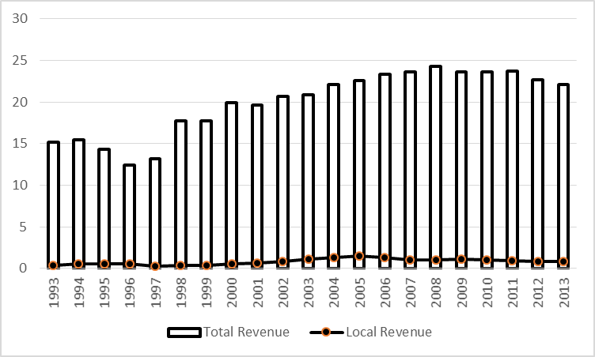
Source (Times New Roman, 10 pts, italic): Eurostat (Times New Roman, 10 pts.)
Note: Social security contributions are included (Times New Roman, 10 pts.)

Body - Times New Roman, 11 pts., justified, 1.0 cm indent, line spacing – at least 14 pt.

2.2. The Second Subparagraph Title (Times New Roman, 11 pts., italic, 0.75 cm indent, left)

Body - Times New Roman, 11 pts., justified, 1.0 cm indent, line spacing – at least 14 pt

3. The Second Paragraph Title of the Paper (Times New Roman, 11 pts, bold, 1.0 cm indent, left)

Body - Times New Roman, 11 pts., justified, 1.0 cm indent, line spacing – at least 14 pt.

4. Conclusion and Recommendations (Times New Roman, 11 pts, bold, 1.0 cm indent, left)

Body - Times New Roman, 11 pts., justified, 1.0 cm indent, line spacing – at least 14 pt.

Acknowledgements (Times New Roman, 11 pts, bold, 1.0 cm indent, left)

Only if needed.

REFERENCES
Books:
Arnheim, R. (1971). Art and visual perception. Berkeley: University of California Press.
When the author and publisher are identical, use the word "Author" as the name of the publisher. American Psychiatric Association. (1994). Diagnostic and statistical manual of mental disorders (4th ed.). Washington, DC: Author.
Festinger, L., Riecken, H., & Schachter, S. (1956). When prophecy fails. Minneapolis: University of Minnesota Press.
Roeder, K., Howdeshell, J., Fulton, L., Lochhead, M., Craig, K., Peterson, R., et.al. (1967). Nerve cells and insect behavior. Cambridge, MA: Harvard University Press.
When a work has more than six authors cite the first six followed by "et al."

Journal articles:
Articles in journals with continuous pagination:
Passons, W. (1967). Predictive validities of the ACT, SAT, and high school grades for first semester GPA and freshman courses. Educational and Psychological Measurement, 27, 1143- 1144.

Articles in journals with non-continuous pagination:
Sawyer, J. (1966). Measurement and prediction, clinical and statistical. Psychological Bulletin, 66 (3), 178-200.

Articles in monthly periodicals:
Chandler-Crisp, S. (1988, May) "Aerobic writing": a writing practice model. Writing Lab Newsletter, pp. 9-11.

Article in an Internet-only journal:
Kawasaki, J. L., & Raven, M.R. (1995). Computer-administered surveys in extension. Journal of Extension, 33, 252-255. Retrieved June 2, 1999, from http://joe.org/joe/index.html
Internet technical or research reports:
University of California, San Francisco, Institute for Health and Aging. (1996, November). Chronic care in America: A 21st century challenge. Retrieved September 9, 2000, from the Robert Wood Foundation Web site: http://www.rwjf.org/library/chrcare

Author’s affiliation, Address, (Times New Roman, 10 pts, Justified)

